**URDF Ankle-Yaw**

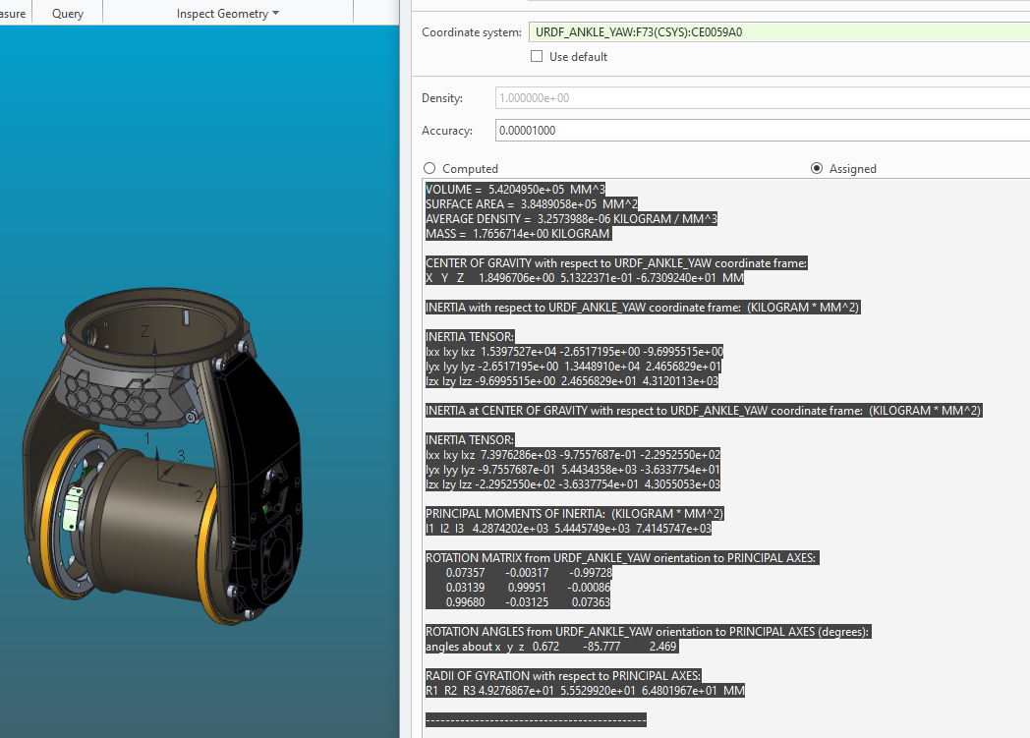

VOLUME = 5.4204950e+05 MM^3

SURFACE AREA = 3.8489058e+05 MM^2

AVERAGE DENSITY = 3.2573988e-06 KILOGRAM / MM^3

MASS = 1.7656714e+00 KILOGRAM

CENTER OF GRAVITY with respect to URDF_ANKLE_YAW coordinate frame:

X Y Z 1.8496706e+00 5.1322371e-01 -6.7309240e+01 MM

INERTIA with respect to URDF_ANKLE_YAW coordinate frame: (KILOGRAM * MM^2)

INERTIA TENSOR:

Ixx Ixy Ixz 1.5397527e+04 -2.6517195e+00 -9.6995515e+00

Iyx Iyy Iyz -2.6517195e+00 1.3448910e+04 2.4656829e+01

Izx Izy Izz -9.6995515e+00 2.4656829e+01 4.3120113e+03

INERTIA at CENTER OF GRAVITY with respect to URDF_ANKLE_YAW coordinate frame: (KILOGRAM * MM^2)

INERTIA TENSOR:

Ixx Ixy Ixz 7.3976286e+03 -9.7557687e-01 -2.2952550e+02

Iyx Iyy Iyz -9.7557687e-01 5.4434358e+03 -3.6337754e+01

Izx Izy Izz -2.2952550e+02 -3.6337754e+01 4.3055053e+03

PRINCIPAL MOMENTS OF INERTIA: (KILOGRAM * MM^2)

I1 I2 I3 4.2874202e+03 5.4445749e+03 7.4145747e+03

ROTATION MATRIX from URDF_ANKLE_YAW orientation to PRINCIPAL AXES:

0.07357 -0.00317 -0.99728

0.03139 0.99951 -0.00086

0.99680 -0.03125 0.07363

ROTATION ANGLES from URDF_ANKLE_YAW orientation to PRINCIPAL AXES (degrees):

angles about x y z 0.672 -85.777 2.469

RADII OF GYRATION with respect to PRINCIPAL AXES:

R1 R2 R3 4.9276867e+01 5.5529920e+01 6.4801967e+01 MM

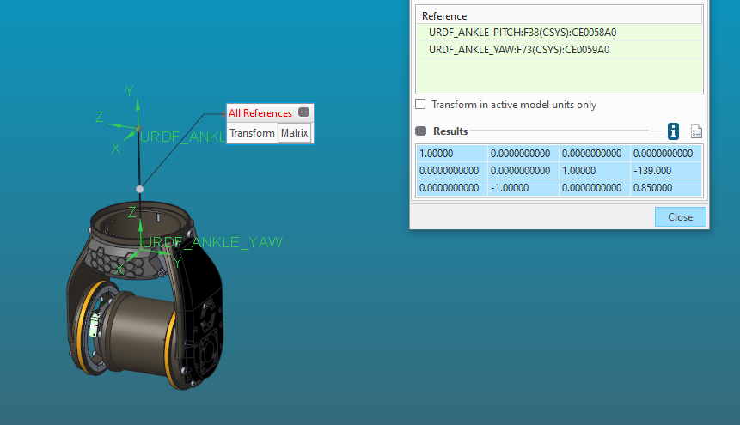

1.00000 0.0000000000 0.0000000000 0.0000000000

0.0000000000 0.0000000000 1.00000 -139.000

0.0000000000 -1.00000 0.0000000000 0.850000